CECS 544 – Lab Assignment 1

Name: Varun Lingabathini

First Page Screenshot

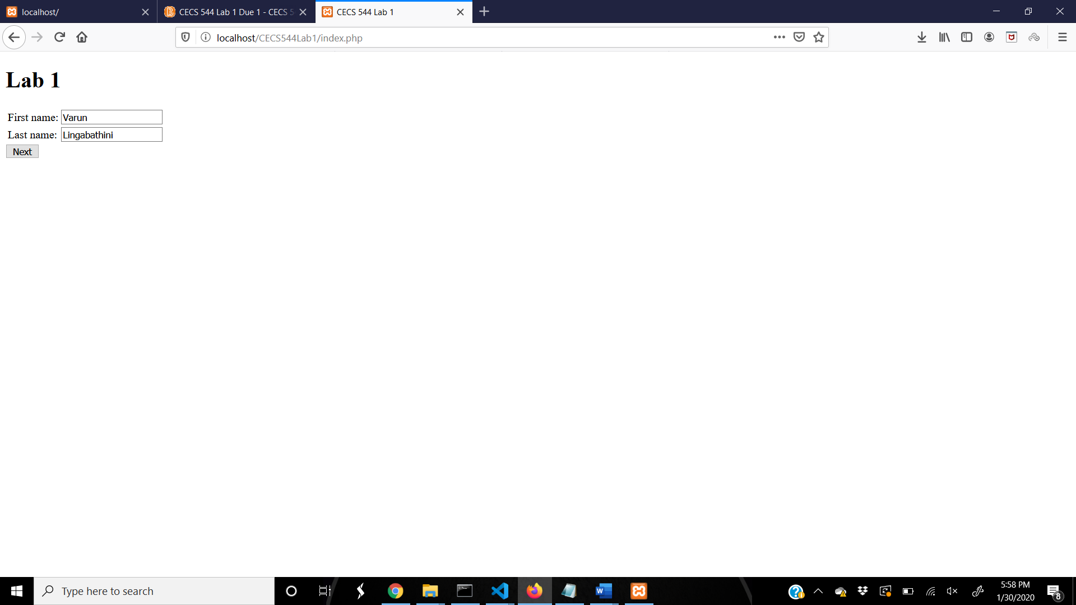

Second Page Screenshot

